Science Manuscript Template Instructions

General instructions on using this template and submitting a manuscript to Science: Thank you for preparing a manuscript for submission to Science. Using this template, or following the guidelines below, will help us in processing your paper and completing the manuscript’s record in our system. Our goal is to automatically identify each section of your manuscript so that we can accurately extract title, authors, abstract, etc. and to enrich it by including reference links and an accurate layout.

Please use the actual template, which starts on page 2. When you are ready to submit, please delete the text on this cover page.

You can submit your paper at https://cts.sciencemag.org. Additional information for authors is available at http://www.sciencemag.org/authors/science-information-authors.

If you are using LaTeX, please convert your paper into a Word .docx file. If this is not possible, please use our LaTeX template (available here) and upload a PDF version of your paper. Some conversion approaches are available here: http://www.tug.org/utilities/texconv/textopc.html.

So that we can extract parts of your paper (even if you do not use this template), begin each section with the specific words listed below, some of which are followed by a colon. Do not use paragraph breaks in the title, author list, or abstract. The author list, corresponding author email(s), and affiliation(s) should be checked carefully because they will be published as listed in the manuscript.

Title: No more than 96 characters and spaces, lacking jargon and abbreviations where possible.
Authors:
Affiliations:
Abstract: 125 words or less.
One Sentence Summary: No more than 125 characters and spaces.
Main Text:
References and Notes: Only a single numbered list should be provided for all references cited in the main text and in the supplementary materials.
Acknowledgments: Split into general, Funding, Author contributions, Competing interests, and Data and materials availability, as described in the template below.
Supplementary Materials: Include a list, noting which references are only cited in the SM.
Fig. #. (Begin each figure caption with a label, “Fig. 1.”, for example, as a new paragraph.)
Table #. (Begin each table caption with a label “Table 1.”, for example, as a new paragraph.)

Please use the .docx format (all versions after Word 2007 for PC and Word 2011 for Mac) and include page numbers in your submitted file. We also encourage use of line numbers. Supplementary Materials (comprising Materials and Methods, figures, and tables) should be in a separate file.

More specific formatting instructions are provided in the template that follows.

Title: Protected area planning to conserve biodiversity in an uncertain world
Authors: Richard Schuster ^{1,2*}, Rachel Buxton¹, Jeffrey O. Hanson¹, Allison D. Binley¹, Jeremy Pittman³, Vivitskaia Tulloch⁴, Frank A. La Sorte⁵, Patrick R. Roehrdanz⁶, Peter H. Verburg⁷, Amanda D. Rodewald^{5,8}, Scott Wilson^{1,9}, Hugh P. Possingham¹⁰, Joseph R. Bennett¹
Affiliations:
¹ Department of Biology, 1125 Colonel By Drive, Carleton University, Ottawa ON, K1S 5B6 Canada.
² Nature Conservancy of Canada, 245 Eglinton Ave East, Suite 410, Toronto, Ontario, M4P 3J1, Canada.
³ School of Planning, University of Waterloo, 200 University Ave W, Waterloo, ON, N2T 3G1, Canada
⁴ Conservation Decisions Lab, Department of Forest and Conservation Sciences, 2424 Main Mall, Vancouver, BC V6T 1Z4, Canada.
⁵ Cornell Lab of Ornithology, Cornell University, Ithaca, NY 14850, USA
⁶ Conservation International, 2100 Crystal Drive #600, Arlington, VA 22202, USA
⁷ Institute for Environmental Studies, VU University Amsterdam, Amsterdam, The Netherlands
⁸ Department of Natural Resources and the Environment, Cornell University, Ithaca, NY 14853, USA.
⁹ Wildlife Research Division, Environment and Climate Change Canada, 1125 Colonel By Drive, Ottawa, Ontario, Canada, K1S 5B6
¹⁰ Centre for Biodiversity and Conservation Science, University of Queensland, St Lucia, Queensland 4067, Australia
*Corresponding author. Email: richard.schuster@glel.carleton.ca
Abstract: Despite being key instruments for conservation, protected areas are vulnerable to risks associated with weak governance, land-use intensification, and climate change. We developed a hierarchical spatial optimization routine to maximize protection of all known terrestrial vertebrate species, and found that expanding the global protected area system while explicitly accounting for such risks requires small (1.6%) increases in land area relative to plans that do not consider risk. Among the three risk categories, the risk of governance failure drove the biggest changes in priority areas for protection. Conserving wide-ranging species required countries with relatively strong governance to protect more land when bordering nations with comparatively weak governance. Our results underscore the need for cross-jurisdictional coordination and demonstrate how risk can be efficiently incorporated into conservation planning.

One-Sentence Summary:
To safeguard biodiversity, protected area planning should incorporate risks associated with climate and land use change, and weak governance.

To safeguard biodiversity, protected areas must account for risk related to climate and land-use change, and weak governance.
Protected area planning for biodiversity should incorporate risk related to climate and land-use change, and weak governance.
Biodiversity protected area planning should incorporate risks related to governance, and climate and land-use change.

Main Text: Protecting habitat is one of the best strategies for stemming the alarming decline of biodiversity (1). As such, international agreements to protect increasing amounts of land area have become cornerstones of efforts to protect biodiversity (2,3). Most current approaches for identifying important areas to protect rely upon estimations of the conservation value of the land for biodiversity (2-5). Seldom articulated in such plans is the tacit assumption that protection will be enforced, effective, and permanent; yet many protected areas are subject to risks caused by weak governance, land-use intensification, and climate change. For example, political instability and corruption can reduce protected area effectiveness (6,7). Likewise, high deforestation rates can increase the risk of degazetting protected areas and failing to meet protection goals (8,9); and the increasing frequency and intensity of extreme weather events can threaten the persistence of species populations within protected areas (10). Thus, effective use of limited conservation resources requires planning for investment in protected areas that accounts for these risks (11,12). Here we demonstrate how accounting for governance, land-use, and climate risks influences decisions for establishing protected areas at a global scale and can ultimately improve the resilience of protected areas and the species they support (13,14).

We considered the following three broad categories of risk, which we defined as factors likely to diminish the long-term effectiveness of protected areas: (i) governance, (ii) land-use, and (iii) climate. For governance risk, we used a national-scale metric that combines six governance indicators from the World Bank (15): accountability, political stability, government effectiveness, regulatory quality, rule of law, and control of corruption (Fig. S1). For land-use risk, we estimated the average change in biodiversity per land-use category using methods (16) that model the risk of biodiversity loss for land systems due to agricultural expansion and intensification (Fig. S2). For climate risk, we used predicted climate velocity, which is the horizontal velocity along the Earth’s surface a hypothetical species would need to maintain a constant temperature as climate changes (Fig. S3) (17). In addition, to illustrate the effect of using alternative risk measures, we use the duration of extreme heat events, calculated using a probabilistic framework that estimates the novelty of temperatures relative to historical year-to-year variation from 1979 to 2019, identifying areas where extreme heat events are likely to have the most significant effects on biodiversity (18) (see Supplementary Material for details). We used these three risk categories for illustrative purposes; the approach we propose is flexible and can easily incorporate additional risk metrics (19).
We considered the influence of risk categories on allocating protection decisions at a global scale in suitable habitat for all 29,350 vertebrate species from the IUCN Red List of Threatened Species (20) using a multi-objective optimization approach. To incorporate risk categories, we built on a classical problem formulation from the systematic conservation planning literature – the minimum set problem - where the objective is to reach species distribution protection targets while accounting for one constraint such as land cost or area (21-23). We expand this approach to include multiple objectives accounting for varying risk in the problem formulation, by treating each risk layer as a separate objective in the problem formulation (24). We use a hierarchical approach that assigns a priority to each objective and optimizes for the objectives in decreasing priority order. At each step, the approach finds the best solution for the current objective, but only from among those that would not degrade the solution quality for higher-priority objectives.
In total 16 planning scenarios were created, such that solutions accounted for all possible combinations of risk categories within each hierarchical level (Table S1). We then compared these risk-based solutions to those produced with a null scenario that adopted the traditional area-minimizing approach to optimization without considering risk (25). Because our scenarios aimed to build upon the current protected area portfolio globally, we incorporated current protected areas into our solutions. For each scenario we set species-based targets based on percentages of suitable habitat protected (26). Specifically, we obtained suitable habitat maps (27), and set target percentages for each species, from 100% for species with less than 1,000 km² of suitable habitat to 10% for those with greater than 250,000 km² of suitable habitat, and linearly interpolated on a log-linear scale between these thresholds (26).
Surprisingly, scenarios that incorporated combinations of the three risk categories increased the priority area by only 1.6% on average (0.08 – 2.52%) compared to the null scenario for protecting species’ suitable habitat. Thus, accounting for risks costs relatively little compared to the potential gains from selecting a more resilient conservation network (Fig. 1). When only looking at scenarios that included one risk factor, climate-change risk based on climate velocity required the greatest increase in global protected area, compared to scenarios only including governance or land use intensification risks (Table S1).
We found that protected areas identified across scenarios overlapped spatially, with the same 11.5 million km² (7.8% of global land area) being prioritized for expansion of the current protected area system in at least eleven scenarios and 8.5 million km² (5.8% of global land area) in all fifteen risk scenarios (Fig. 2). These “no regrets” areas provide examples of places that should be immediate priorities for international agencies aiming to maximize the resilience of protected area networks, as they are robust to assumptions about the relative importance of risk factors. Example countries that have contiguous areas of high overlap among different scenarios are Canada, Kenya and Peru (Fig. S4). There was considerable overlap among the priorities across scenarios within Conservation International’s global biodiversity hotspots (28), but many high overlap areas lie either outside of (53.3%) or in small areas within hotspots (Fig. S5).
There were some important shifts in locations identified as high priority for protection among risk scenarios (Fig. 3; Table S2), with the largest shift being for the risk of weak governance (Fig. S6). Compared to null scenarios, those considering governance risk required protection of greater land area, even for countries with relatively effective governance. This was especially true for protecting wide-ranging species and when neighboring countries had weak governance. For example, many vertebrate species ranges span northeastern Russia and Finland, one of the most iconic being caribou (Rangifer tarandus), which has an IUCN conservation status of vulnerable. Because Russia has low scores for ‘voice and accountability, rule of law, and control of corruption’ (Table S3), whereas Finland has relatively high governance scores, the scenarios including governance pressures led to a selection of 36.4% of Finland’s land area compared to the null scenario with 16.2% (Fig. 4).
Land-use and climate change also influenced variation in priority locations for protection compared to the null scenario. For example, large areas of Sierra Leone are experiencing high risk of biodiversity loss due to expanding intensive agricultural land-use practices (Fig. S2), whereas this same risk is lower in neighboring Liberia. The scenario including land-use risk selected 32.1% of the land area in Liberia compared to 22.5% in the null scenario (Fig. 4). Large areas of Hungary and Serbia have high predicted climate velocity (Fig. S3), whereas most of nearby Kosovo has lower predicted climate velocity. Scenarios including climate impact risk selected 20.4% of Kosovo’s land area compared to the null scenario with 10.2% (Fig. 4). Including the risk metric predicting frequency of extreme events (18) (Fig. S7) resulted in different priority areas in some cases. For example, large areas of Libya, which is experiencing fewer extreme heat events than neighboring countries, were prioritized in this scenario and not in the null scenario. This difference between climate risk scenarios highlights the need for agencies to carefully consider their choices of risk metrics and suggests that smaller-scale planning exercises should choose metrics that are most relevant for each region.
Overall, our results emphasize the importance of coordinating initiatives to plan conservation across jurisdictions (29) and identifying countries where collaborative opportunities promote resilient protected area systems. To illustrate this point, we consider the great green macaw (Ara ambiguus), with <2500 individuals remaining (30) and a range that stretches from southern Honduras to western Colombia. Because great green macaw habitat spans several countries differing in governance, land use, and climate risk, coordinated efforts among countries will be necessary for the species to persist in the future. Such cooperative governance frameworks (31) are especially important for countries supporting wide-ranging species that are expected to be impacted by climate, land-use, and governance risk across borders (Fig. 3). These governance frameworks, both within and among countries, would need to be developed in an environmentally just and equitable way to deliver benefits to biodiversity and local communities (32).
In contrast, few priorities changed - and protection needs remained high - for countries with high rates of endemism, even amid high risk from climate change, land use, and weak governance. Moreover, some countries with a large proportion of their land already protected, such as Brazil, which has protected 30.3% of its land area, had lower differences between scenarios that incorporate risk and the null scenario, despite having high climate, land-use, and governance risk. This highlights the importance of further considering the effectiveness of existing protected areas in planning analyses, in tropical areas where cropland conversion in protected areas has increased to similar rates outside protected areas (33).
Previous work has incorporated individual risk factors analogous to those we used, including governance (34,35), climate change (36) and land-use change (37,38). Yet, our results show that protected area expansion decisions can be profoundly influenced by all three risk factors combined. Our flexible framework and methods can allow conservation agencies to set their own priorities from local to global scales and incorporate different metrics to assess the relevance of different forms and levels of risk.
The conservation community has traditionally neglected to estimate how future changes in climate (39), land-use (38), and socio-economic conditions might compromise the effectiveness of protected areas. Our results show that the spatial distribution of protected areas, rather than the land area per se, can be profoundly influenced by risk, particularly the risk of weak governance. Incorporating risk into decision-making adds <1% to the total global area required to meet biodiversity targets. Thus, accounting for risk comes at limited extra cost which is likely outweighed by increased likelihood of achieving global biodiversity targets. Our results also emphasize the importance of cross-jurisdictional conservation initiatives, especially in adjacent countries sharing wide-ranging species where risk varies considerably from country to country. Considering risk in conservation decision-making will result in more resilient and effective conservation plans into the future to help safeguard our planet’s biodiversity in the face of the current extinction crisis.

References and Notes
- J. E. Watson, N. Dudley, D. B. Segan, M. Hockings, The performance and potential of protected areas. Nature 515, 67–73 (2014).

- CBD (Convention on Biological Diversity), Aichi Biodiversity Targets. https://www.cbd.int/sp/targets/ (2020).

- CBD (Convention on Biological Diversity), Zero draft of the post-2020 global biodiversity framework. Available at https://www.cbd.int/doc/c/efb0/1f84/a892b98d2982a829962b6371/wg2020-02-03-en.pdf (2020).

- T. M. Brooks, R. A. Mittermeier, G. A. B. da Fonseca, J. Gerlach, M. Hoffmann, J. F. Lamoreux, C. G. Mittermeier, J. D. Pilgrim, A. S. L. Rodrigues, Global biodiversity conservation priorities. Science 313, 58–61 (2006).

- O. Venter, R. A. Fuller, D. B. Segan, J. Carwardine, T. Brooks, S. H. Butchart, M. Di Marco, T. Iwamura, L. Joseph, D. O'Grady, H. P. Possingham, Targeting Global Protected Area Expansion for Imperiled Biodiversity. PLOS Biol. 12, e1001891 (2014).

- K. Schulze, K. Knights, L. Coad, J. Geldmann, F. Leverington, A. Eassom, M. Marr, S. H. M. Butchart, M. Hockings, N. D. Burgess, An assessment of threats to terrestrial protected areas. Conserv. Lett. 11, e12435 (2018).

- E. Hammill, A. I. T. Tulloch, H. P. Possingham, N. Strange, K. A. Wilson, Factoring attitudes towards armed conflict risk into selection of protected areas for conservation. Nat. Commun. 7, 11042 (2016).

- A. T. Tesfaw, A. Pfaff, R. E. G. Kroner, S. Qin, R. Medeiros, M. B. Mascia, Land-use and land-cover change shape the sustainability and impacts of protected areas. Proc. Natl. Acad. Sci. 115, 2084–2089 (2018).

- R. E. G Kroner, S. Qin, C. N. Cook, R. Krithivasan, S. M. Pack, O. D. Bonilla, K. A. Cort-Kansinally, B. Coutinho, M. Feng, M.I.M. Garcia, Y. He, The uncertain future of protected lands and waters. Science 364, no. 6443 (2019): 881-886.

- S. L. Maxwell, N. Butt, M. Maron, C. A. McAlpine, S. Chapman, A. Ullmann, D. B. Segan, J. E. M. Watson, Conservation implications of ecological responses to extreme weather and climate events. Divers. Distrib. 25, 613–625 (2019).

- M. F. McBride, K. A. Wilson, M. Bode, H. P. Possingham, Incorporating the effects of socioeconomic uncertainty into priority setting for conservation investment. Conserv. Biol. 21, 1463–1474 (2007).

- D. Alagador, J. O. Cerdeira, M. B. Araújo, Shifting protected areas: scheduling spatial priorities under climate change. J. Appl. Ecol. 51, 703–713 (2014).

- J. McGowan, R. Weary, L. Carriere, E. T. Game, J. L. Smith, M. Garvey, H. P. Possingham, Prioritizing debt conversion opportunities for marine conservation. Conserv. Biol. 34, 1065–1075 (2020).

- C. D. Kuempel, K. R. Jones, J. E. M. Watson, H. P. Possingham, Quantifying biases in marine-protected-area placement relative to abatable threats. Conserv. Biol. 33, 1350–1359 (2019).

- D. Kaufmann, A. Kraay, M. Mastruzzi, The worldwide governance indicators: methodology and analytical issues. Hague J. Rule Law 3, 220–246 (2011).

- L. Kehoe, A. Romero-Muñoz, E. Polaina, L. Estes, H. Kreft, T. Kuemmerle, Biodiversity at risk under future cropland expansion and intensification. Nat. Ecol. Evol. 1, 1129–1135 (2017).

- S. R. Loarie, P. B. Duffy, H. Hamilton, G. P. Asner, C. B. Field, D. D. Ackerly, The velocity of climate change. Nature 462, 1052-1055 (2009).

- F.A. La Sorte, A. Johnston, T. R. Ault, Global trends in the frequency and duration of temperature extremes. Clim. Change 166, 1-14 (2021).
- R. A. Garcia, M. Cabeza, C. Rahbek, M. B. Araújo, Multiple dimensions of climate change and their implications for biodiversity. Science 344, 1247579 (2014).

- IUCN. The IUCN red list of threatened species. version 1.18. Available at https://www.iucnredlist.org/ (2019).

- C. R. Margules, R. L. Pressey, Systematic conservation planning. Nature 405, 243–53 (2000).

- A. Moilanen, K. Wilson, H. Possingham, Spatial conservation prioritization: quantitative methods and computational tools (Oxford University Press, 2009).

- I. R. Ball, H. P. Possingham, M. E. Watts, “Marxan and relatives: Software for spatial conservation prioritization” in Spatial conservation prioritisation: Quantitative methods and computational tools (Oxford University Press, 2009), pp. 185–195.

- K. Deb, “Multi-objective optimization” in Search methodologies (Springer, 2014), pp. 403–449.

- IUCN, Post-2020 global biodiversity framework. Available at https://www.iucn.org/theme/global-policy/our-work/convention-biological-diversity-cbd/post-2020-global-biodiversity-framework (2018).

- J. O. Hanson, J. R. Rhodes, S. H. M. Butchart, G. M. Buchanan, C. Rondinini, G. F. Ficetola, R. A. Fuller, Global conservation of species’ niches. Nature 580, 232–234 (2020).

- T. M. Brooks, S. L. Pimm, H. R. Akçakaya, G. M. Buchanan, S. H. M. Butchart, W. Foden, C. Hilton-Taylor, M. Hoffmann, C. N. Jenkins, L. Joppa, B. V. Li, V. Menon, N. Ocampa-Peñuela, C. Rondinini, Measuring terrestrial area of habitat (AOH) and its utility for the IUCN red list. Trends Ecol. Evol. 34, 977–986 (2019).

- N. Myers, R. A. Mittermeier, C. G. Mittermeier, G. A. B. da Fonseca, J. Kent, Biodiversity hotspots for conservation priorities. Nature 403, 853–858 (2000).

- M. Dallimer, N. Strange, Why socio-political borders and boundaries matter in conservation. Trends Ecol. Evol. 30, 132–139 (2015).

- Bird Life International, Ara ambiguus. The IUCN red list of threatened species 2020: e.T22685553A172908289. Available at https://dx.doi.org/10.2305/IUCN.UK.2020-3.RLTS.T22685553A172908289.en (2016).

- R. L. Miller, H. Marsh, C. Benham, M. A. Hamann, Framework for improving the cross-jurisdictional governance of a marine migratory species. Conserv. Sci. Pract. 1, e58 (2019).

- A. Martin, S. McGuire, S. Sullivan, Global environmental justice and biodiversity conservation. Geogr. J. 179, 122–131 (2013).

- J. Geldmann, A. Manica, N. D. Burgess, L. Coad, A. Balmford, A global-level assessment of the effectiveness of protected areas at resisting anthropogenic pressures. Proc. Natl. Acad. Sci. 116, 23209–23215 (2019).

- M. B. Mascia, S. Pailler, Protected area downgrading, downsizing, and degazettement (PADDD) and its conservation implications. Conserv. Lett. 4, 9–20 (2011).

- J. F. Eklund, M. D. M. Cabeza-Jaimejuan, Quality of governance and effectiveness of protected areas: crucial concepts for conservation planning. Ann. N. Y. Acad. Sci. 1399, 27–41(2017).

- S. Hoffmann, S. D. Irl, C. Beierkuhnlein, Predicted climate shifts within terrestrial protected areas worldwide. Nat. Commun. 10, 1–10 (2019).

- F. M. Pouzols, T. Toivonen, E. Di Minin, A. S. Kukkala, P. Kullberg, J. Kuusterä, J. Lehtomäki, H. Tenkanen, P. H. Verburg, A. Moilanen, Global protected area expansion is compromised by projected land-use and parochialism. Nature 516, 383–386 (2014).

- E. Di Minin, R. Slotow, L. T. Hunter, F. M. Pouzols, T. Toivonen, P. H. Verburg, N. Leader-Williams, L. Petracca, A. Moilanen, Global priorities for national carnivore conservation under land use change. Sci. Rep. 6, 23814 (2016).

- L. T. Kelly, K. M. Giljohann, A. Duane, N. Aquilué, S. Archibald, E. Batllori, A. F. Bennett, S. T. Buckland, Q. Canelles, M. F. Clarke, M. J. Fortin, Fire and biodiversity in the Anthropocene. Science 370, 6519 (2020).

- J. A. Hartigan, M. A. Wong, Algorithm AS 136: A K-Means Clustering Algorithm. J. R. Stat. Soc. Ser. C Appl. Stat. 28, 100–108 (1979).

- S. H. M. Butchart, M. Clarke, R. J. Smith, R. E. Sykes, J. P. Scharlemann, M. Harfoot, G. M. Buchanan, A. Angulo, A. Balmford, B. Bertzky, T. M. Brooks, Shortfalls and solutions for meeting national and global conservation area targets. Conserv. Lett. 8, 329–337 (2015).

- C. A. Runge, J. E. M Watson, S. H. M. Butchart, J. O. Hanson, H. P. Possingham, R. A. Fuller. Protected areas and global conservation of migratory birds. Science 350, 1255–1258 (2015).

- A. S. L. Rodrigues, H. R. Akcakaya, S. J. Andelman, M. I. Bakarr, L. Boitani, T. M. Brooks, J. S. Chanson, L. D. Fishpool, G. A. da Fonseca, K. J. Gaston, M. Hoffmann, Global gap analysis: priority regions for expanding the global protected-area network. Bioscience 54, 1092–1100 (2004).

- IUCN Red List, UNEP-WCMC, Species Range Polygons ver . Available at https://www.iucnredlist.org/resources/other-spatial-downloads. Downloaded YYYY-MM-DD (2020).

- Bird Life International, Spatial Data Zone – Birds of the World Species Distribution Data. Available at http://datazone.birdlife.org/species/requestdis. Downloaded 6-1-2020 (2020).

- L. Santini, S. H. M. Butchart, C. Rondinini, A. Benítez-López, J. P. Hilbers, A. M. Schipper, M. Cengic, J. A. Tobias, M. A. J. Huijbregts, Applying habitat and population-density models to land-cover time series to inform IUCN red list assessments. Conserv. Biol. 33, 1084–1093 (2019).

- S. E. Fick, R. J. Hijmans, WorldClim 2: new 1-km spatial resolution climate surfaces for global land areas. Int. J. Climatol. 37, 4302–4315.

- Global administrative areas. GADM database of global administrative areas, version ? Available at http://gadm.org/. Downloaded 2019-10-31 (2017).

- UNEP-WCWC, IUCN, Protected planet: the world database on protected areas. Available at https://www.protectedplanet.net. Downloaded YYYY-MM-DD (2021).

- UNEP-WCWC, IUCN, Protected planet: Calculating protected area coverage. Available at https://www.protectedplanet.net/c/calculating-protected-area-coverage (2021).

- K. L. Coetzer, E. T. Witkowski, B. F. Erasmus, Reviewing biosphere reserves globally: effective conservation action or bureaucratic label? Biol. Rev. 89, 82–104 (2014).

- M. D. Barnes, I. D. Craigie, L. B. Harrison, J. Geldmann, B. Collen, S. Whitmee, A. Balmford, N. D. Burgess, T. Brooks, M. Hockings, S. Woodley, Wildlife population trends in protected areas predicted by national socio-economic metrics and body size. Nat. Commun. 7, 12747 (2016).

- Z. Baynham-Herd, T. Amano, W. J. Sutherland, P. F. Donald, Governance explains variation in national responses to the biodiversity crisis. Environ. Conserv. 45, 407–418 (2018).

- S. van Asselen, P. H. Verburg, A Land System representation for global assessments and land-use modeling. Glob. Change Biol. 18, 3125–3148 (2012).

- L. N. Hudson, T. Newbold, S. Contu, S. L. Hill, I. Lysenko, A. De Palma, H. R. Phillips, R. A. Senior, D. J. Bennett, H. Booth, A. Choimes, D. L. Correia, J. Day, S. Echeverría-Londoño, M. Garon, M. L. Harrison, D. J. Ingram, M. Jung, V. Kemp, L. Kirkpatrick, C. D. Martin, Y. Pan, H. J. White, J. Aben, S. Abrahamczyk, G. B. Adum, V. Aguilar-Barquero, M. A. Aizen, M. Ancrenaz, E. Arbeláez-Cortés, I. Armbrecht, B. Azhar, A. B. Azpiroz, L. Baeten, A. Báldi, J. E. Banks, J. Barlow, P. Batáry, A. J. Bates, E. M. Bayne, P. Beja, Å. Berg, N. J. Berry, J. E. Bicknell, J. H. Bihn, K. Böhning-Gaese, T. Boekhout, C. Boutin, J. Bouyer, F. Q. Brearley, I. Brito, J. Brunet, G. Buczkowski, E. Buscardo, J. Cabra-García, M. Calviño-Cancela, S. A. Cameron, E. M. Cancello, T. F. Carrijo, A. L. Carvalho, H. Castro, A. A. Castro-Luna, R. Cerda, A. Cerezo, M. Chauvat, F. M. Clarke, D. F. Cleary, S. P. Connop, B. D’Aniello, P. G. da Silva, B. Darvill, J. Dauber, A. Dejean, T. Diekötter, Y. Dominguez-Haydar, C. F. Dormann, B. Dumont, S. G. Dures, M. Dynesius, L. Edenius, Z. Elek, M. H. Entling, N. Farwig, T. M. Fayle, A. Felicioli, A. M. Felton, G. F. Ficetola, B. K. Filgueiras, S. J. Fonte, L. H. Fraser, D. Fukuda, D. Furlani, J. U. Ganzhorn, J. G. Garden, C. Gheler-Costa, P. Giordani, S. Giordano, M. S. Gottschalk, D. Goulson, A. D. Gove, J. Grogan, M. E. Hanley, T. Hanson, N. R. Hashim, J. E. Hawes, C. Hébert, A. J. Helden, J. A. Henden, L. Hernández, F. Herzog, D. Higuera-Diaz, B. Hilje, F. G. Horgan, R. Horváth, K. Hylander, P. Isaacs-Cubides, M. Ishitani, C. T. Jacobs, V. J. Jaramillo, B. Jauker, M. Jonsell, T. S. Jung, V. Kapoor, V. Kati, E. Katovai, M. Kessler, E. Knop, A. Kolb, Á. Kőrösi, T. Lachat, V. Lantschner, V. Le Féon, G. LeBuhn, J. P. Légaré, S. G. Letcher, N. A. Littlewood, C. A. López-Quintero, M. Louhaichi, G. L. Lövei, M. E. Lucas-Borja, V. H. Luja, K. Maeto, T. Magura, N. A. Mallari, E. Marin-Spiotta, E. J. Marshall, E. Martínez, M. M. Mayfield, G. Mikusinski, J. C. Milder, J. R. Miller, C. L. Morales, M. N. Muchane, M. Muchane, R. Naidoo, A. Nakamura, S. Naoe, G. Nates-Parra, D. A. Navarrete Gutierrez, E. L. Neuschulz, N. Noreika, O. Norfolk, J. A. Noriega, N. M. Nöske, N. O’Dea, W. Oduro, C. Ofori-Boateng, C. O. Oke, L. M. Osgathorpe, J. Paritsis, A. Parra-H, N. Pelegrin, C. A. Peres, A. S. Persson, T. Petanidou, B. Phalan, T. K. Philips, K. Poveda, E. F. Power, S. J. Presley, V. Proença, M. Quaranta, C. Quintero, N. A. Redpath-Downing, J. L. Reid, Y. T. Reis, D. B. Ribeiro, B. A. Richardson, M. J. Richardson, C. A. Robles, J. Römbke, L. P. Romero-Duque, L. Rosselli, S. J. Rossiter, T. H. Roulston, L. Rousseau, J. P. Sadler, S. Sáfián, R. A. Saldaña-Vázquez, U. Samnegård, C. Schüepp, O. Schweiger, J. L. Sedlock, G. Shahabuddin, D. Sheil, F. A. Silva, E. M. Slade, A. H. Smith-Pardo, N. S. Sodhi, E. J. Somarriba, R. A. Sosa, J. C. Stout, M. J. Struebig, Y. H. Sung, C. G. Threlfall, R. Tonietto, B. Tóthmérész, T. Tscharntke, E. C. Turner, J. M. Tylianakis, A. J. Vanbergen, K. Vassilev, H. A. Verboven, C. H. Vergara, P. M. Vergara, J. Verhulst, T. R. Walker, Y. Wang, J. I. Watling, K. Wells, C. D. Williams, M. R. Willig, J. C. Woinarski, J. H. Wolf, B. A. Woodcock, D. W. Yu, A. S. Zaitsev, B. Collen, R. M. Ewers, G. M. Mace, D. W. Purves, J. P. Scharlemann, A. Purvis, The PREDICTS database: a global database of how local terrestrial biodiversity responds to human impacts. Ecol. Evol. 4, 4701–4735 (2014).

- T. Newbold, L. N. Hudson, S. L. L. Hill, S. Contu, I. Lysenko, R. A. Senior, L. Börger, D. J. Bennett, A. Choimes, B. Collen, J. Day, A. De Palma, S. Díaz, S. Echeverria-Londoño, M. J. Edgar, A. Feldman, M. Garon, M. L. K. Harrison, T. Alhusseini, D. J. Ingram, Y. Itescu, J. Kattge, V. Kemp, L. Kirkpatrick, M.Kleyer, D. L. P. Correia, C. D. Martin, S. Meiri, M. Novosolov, Y. Pan, H. R. P. Phillips, D. W. Purves, A. Robinson, J. Simpson, S. L. Tuck, E. Weiher, H. J. White, R. M. Ewers, G. M. Mace, J. P. W. Scharlemann, A. Purvis, Global effects of land use on local terrestrial biodiversity. Nature 520, 45–50 (2015).

- B. Sandel, L. Arge, B. Dalsgaard, R. G. Davies, K. J. Gaston, W. J. Sutherland, J-C. Svenning, The Influence of Late Quaternary Climate-Change Velocity on Species Endemism. Science 334, 660 (2011).

- A. AghaKouchak, F. Chiang, L. S. Huning, C. A. Love, I. Mallakpour, O. Mazdiyasni, H. Moftakhari, S. M. Papalexiou, E. Ragno, M. Sadegh. Climate extremes and compound hazards in a warming world. Annu. Rev. Earth Planet. Sci. 48, 519–548 (2020).

- N. S. Diffenbaugh, D. Singh, J. S. Mankin, D. E. Horton, D. L. Swain, D. Touma, A. Charland, Y. Liu, M. Haugen, M. Tsiang, B. Rajaratnam, Quantifying the influence of global warming on unprecedented extreme climate events. Proc. Natl. Acad. Sci. 114, 4881–4886 (2017).

- A. G. Brooke, M. L. Bell, Heat Waves in the United States: Mortality Risk during Heat Waves and Effect Modification by Heat Wave Characteristics in 43 U.S. Communities. Environ. Health Perspect. 119, 210–218 (2011).

- D. S. Battisti, R. L. Naylor, Historical warnings of future food insecurity with unprecedented seasonal heat. Science 323, 240–244 (2009).

- D. Mitchell, C. Heaviside, S. Vardoulakis, C. Huntingford, G. Masato, B. P. Guillod, P. Frumhoff, A. Bowery, D. Wallom, M. Allen, Attributing human mortality during extreme heat waves to anthropogenic climate change. Environ. Res. Lett. 11, 074006 (2016).

- R. M. B. Harris, L.J. Beaumont, T. R. Vance, C. R. Tozer, T. A. Remenyi, S. E. Perkins-Kirkpatrick, P. J. Mitchell, A. B. Nicotra, S. McGregor, N. R. Andrew, M. Letnic, Biological responses to the press and pulse of climate trends and extreme events. Nat. Clim. Change 8, 579–587 (2018).

- M. Maron, C. A. McAlpine, J. E. M. Watson, S. Maxwell, P. Barnard, Climate-induced resource bottlenecks exacerbate species vulnerability: a review. Divers. Distrib. 21, 731–743 (2015).

- P. R. Grant, B. R. Grant, R. B. Huey, M. T. J. Johnson, A. H. Knoll, J. Schmitt, Evolution caused by extreme events. Philos. Trans. R. Soc. B Biol. Sci. 372, 20160146 (2017).

- V. P. Gutschick, H. BassiriRad, Extreme events as shaping physiology, ecology, and evolution of plants: toward a unified definition and evaluation of their consequences. New Phytol. 160, 21–42 (2003).

- E. Cremonese, G. Filippa, M. Galvagno, C. Siniscalco, L. Oddi, U. M. di Cella, M. Migliavacca. Heat wave hinders green wave: The impact of climate extreme on the phenology of a mountain grassland. Agric. For. Meteorol. 247, 320–330 (2017).

- F. A. La Sorte, W. M. Hochachka, A. Farnsworth, A. A. Dhondt, D. Sheldon, The implications of mid-latitude climate extremes for North American migratory bird populations. Ecosphere 7, e01261 (2016).

- D. Fenner, A. Holtmann, A. Krug, D. Scherer, Heat waves in Berlin and Potsdam, Germany – Long-term trends and comparison of heat wave definitions from 1893 to 2017. Int. J. Climatol. 39, 2422–2437 (2019).

- T. T. Smith, B. F. Zaitchik, J. M. Gohlke, Heat waves in the United States: definitions, patterns and trends. Clim. Change 118, 811–825 (2013).

- L. E. McPhillips, H. Chang, M.V. Chester, Y. Depietri, E. Friedman, N.B. Grimm, J. S. Kominoski, T. McPhearson, P. Méndez‐Lázaro, E.J. Rosi, J. S. Shiva, Defining Extreme Events: A Cross-Disciplinary Review. Earths Future 6, 441–455 (2018).

- H. Hersbach, B. Bell, P. Berrisford, G. Biavati, A. Horányi, J. M. Sabater, J. Nicolas, C. Peubey, R. Radu, I. Rozum, D. Schepers, A. Simmons, C. Soci, D. Dee, J-N. Thépaut, ERA5 hourly data on single levels from 1979 to present. Copernicus Climate Change Service (C3S) Climate Data Store (CDS). (Accessed on < DD-MMM-YYYY >), 10.24381/cds.adbb2d47 (2018).

- H. Hersbach, W. Bell, P. Berrisford, A. Horányi, J. M. Sabater, J. Nicolas, R. Radu, D. Schepers, A. Simmons, C. Soci, D. Dee, Global reanalysis: goodbye ERA-Interim, hello ERA5. ECMFW Newsletter 159, 17–24 Available at doi:10.21957/vf291hehd7 (2019).

- Hoffmann, L. G. Günther, D. Li, O. Stein, X. Wu, S. Griessbach, Y. Heng, P. Konopka, R. Müller, B. Vogel, J. S. Wright, From ERA-Interim to ERA5: the considerable impact of ECMWF’s next-generation reanalysis on Lagrangian transport simulations. Atmospheric Chem. Phys. 19, 3097–3124 (2019).

- Huang, N. E. Z. Shen, S. R. Long, M. C. Wu, H. H. Shih, Q. Zheng, N.-C. Yen, C. C. Tung, H. H. Liu. The empirical mode decomposition and the Hilbert spectrum for nonlinear and non-stationary time series analysis. Proc. R. Soc. Lond. Ser. Math. Phys. Eng. Sci. 454, 903–995 (1998).

- Z. Wu, N. E. Huang, S. R. Long, C.-K. Peng, On the trend, detrending, and variability of nonlinear and nonstationary time series. Proc. Natl. Acad. Sci. 104, 14889–14894 (2007).

- S. Ferrari, F. Cribari-Neto, Beta Regression for Modelling Rates and Proportions. J. Appl. Stat. 31, 799–815 (2004).

- A. B. Simas, W. Barreto-Souza, A. V. Rocha, Improved estimators for a general class of beta regression models. Comput. Stat. Data Anal. 54, 348–366 (2010).

- S. L. Pimm, P. Raven, Extinction by numbers. Nature 403, 843-845 (2000).
Acknowledgments: Acknowledgments follow the references and notes list but are not numbered. Start with text that acknowledges non-author contributions and then complete each of the sections below as separate paragraphs.
Funding: Provide complete funding information, including grant numbers, complete funding agency names, and recipient’s initials. Each funding source should be listed in a separate paragraph.
Examples:
National Institutes of Health grant U12AB123456 (PV, CHO)
National Institutes of Health grant R01AB123456 (PV, GS)
William K. Bowes Jr Foundation (PV)
German Research Foundation grant AB 1234/1-1
Office of Biological and Environmental Research of the U.S. Department of Energy Atmospheric System Research Program Interagency Agreement grant DE-SC0000001
National Institute of Health Research UK
UK-China Research and Innovation Partnership Fund through the Met Office Climate Science for Service Partnership (CSSP) China as part of the Newton Fund
Author contributions: Each author’s contribution(s) to the paper should be listed [we encourage you to follow the CRediT model]. Each CRediT role should have its own line, and there should not be any punctuation in the initials.
Conceptualization: RS, RB, JRB
Methodology: RS, RB, JRB, ADB
Investigation: RS
Visualization: RS
Funding acquisition: RS, JRB
Writing – original draft: RS, RB, JRB
Writing – review & editing: RS, RB, JRB, ADB
Competing interests: The authors declare no competing interests.
Data and materials availability: All data, scripts and full results are available on Open Science Framework (OSF) and will be assigned a DOI once the manuscript is in print: https://osf.io/e2fuw/?view_only=46eb2e525daf42d29df318a92762d885

Supplementary Materials
Materials and Methods
Figs. S1 to S9
Tables S1 to S4
Captions for Data S1 to Sx
References (40 – 79)

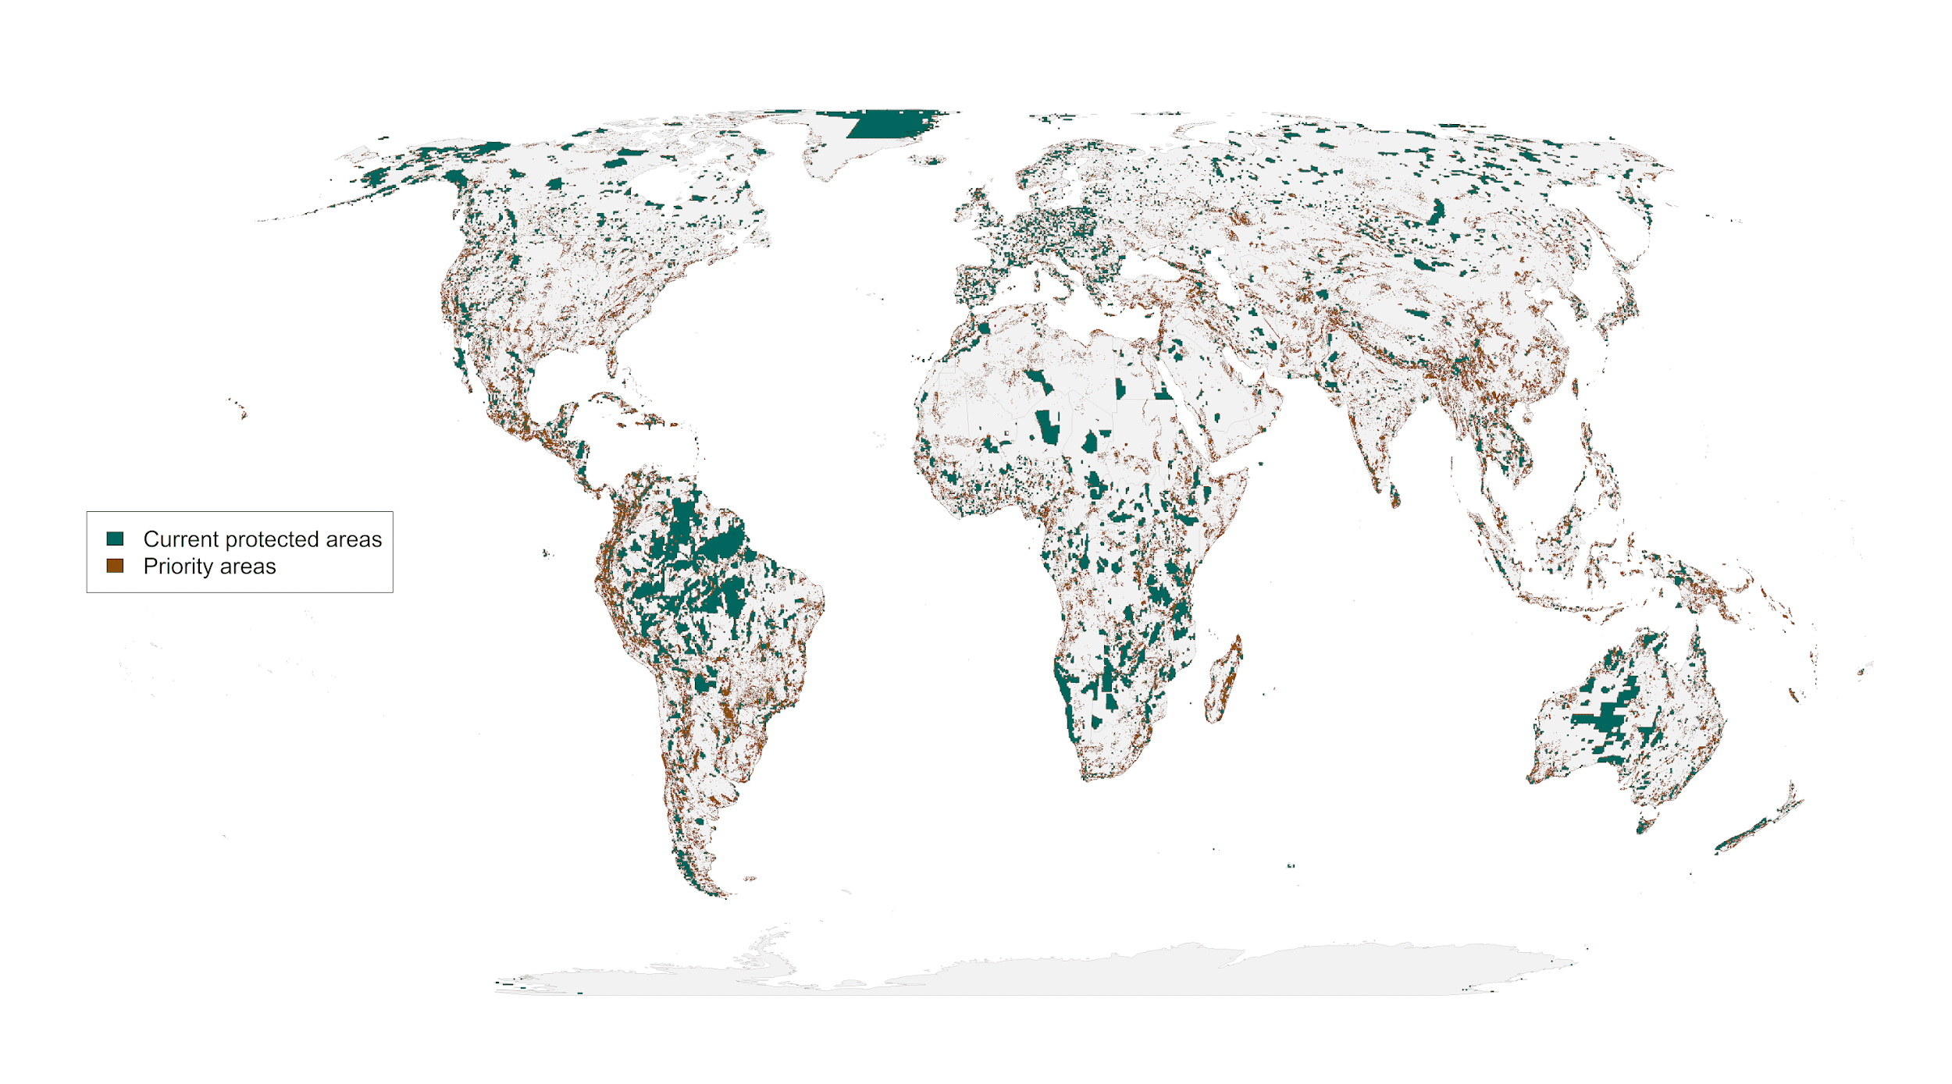
Figure 1: Spatial representation of priority areas for protection to account for governance, land use and climate risk. Accounting for these risks to protected area effectiveness to produce more resilient conservation networks would require 23.5% of land surface to reach suitable habitat protection goals (26) for vertebrate species from the IUCN Red List of Threatened Species (20).

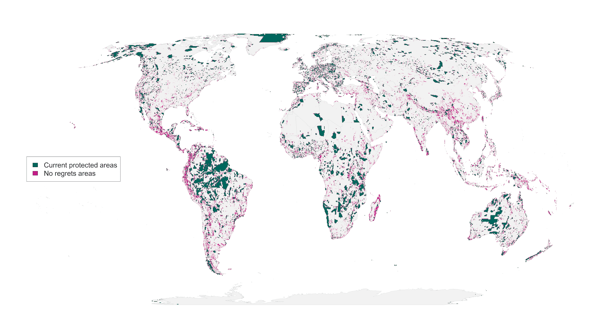 Figure 2: “No regrets” areas comprising 8.5 million km² of land that was identified as priority habitat for protection regardless of the risks included in our analysis.
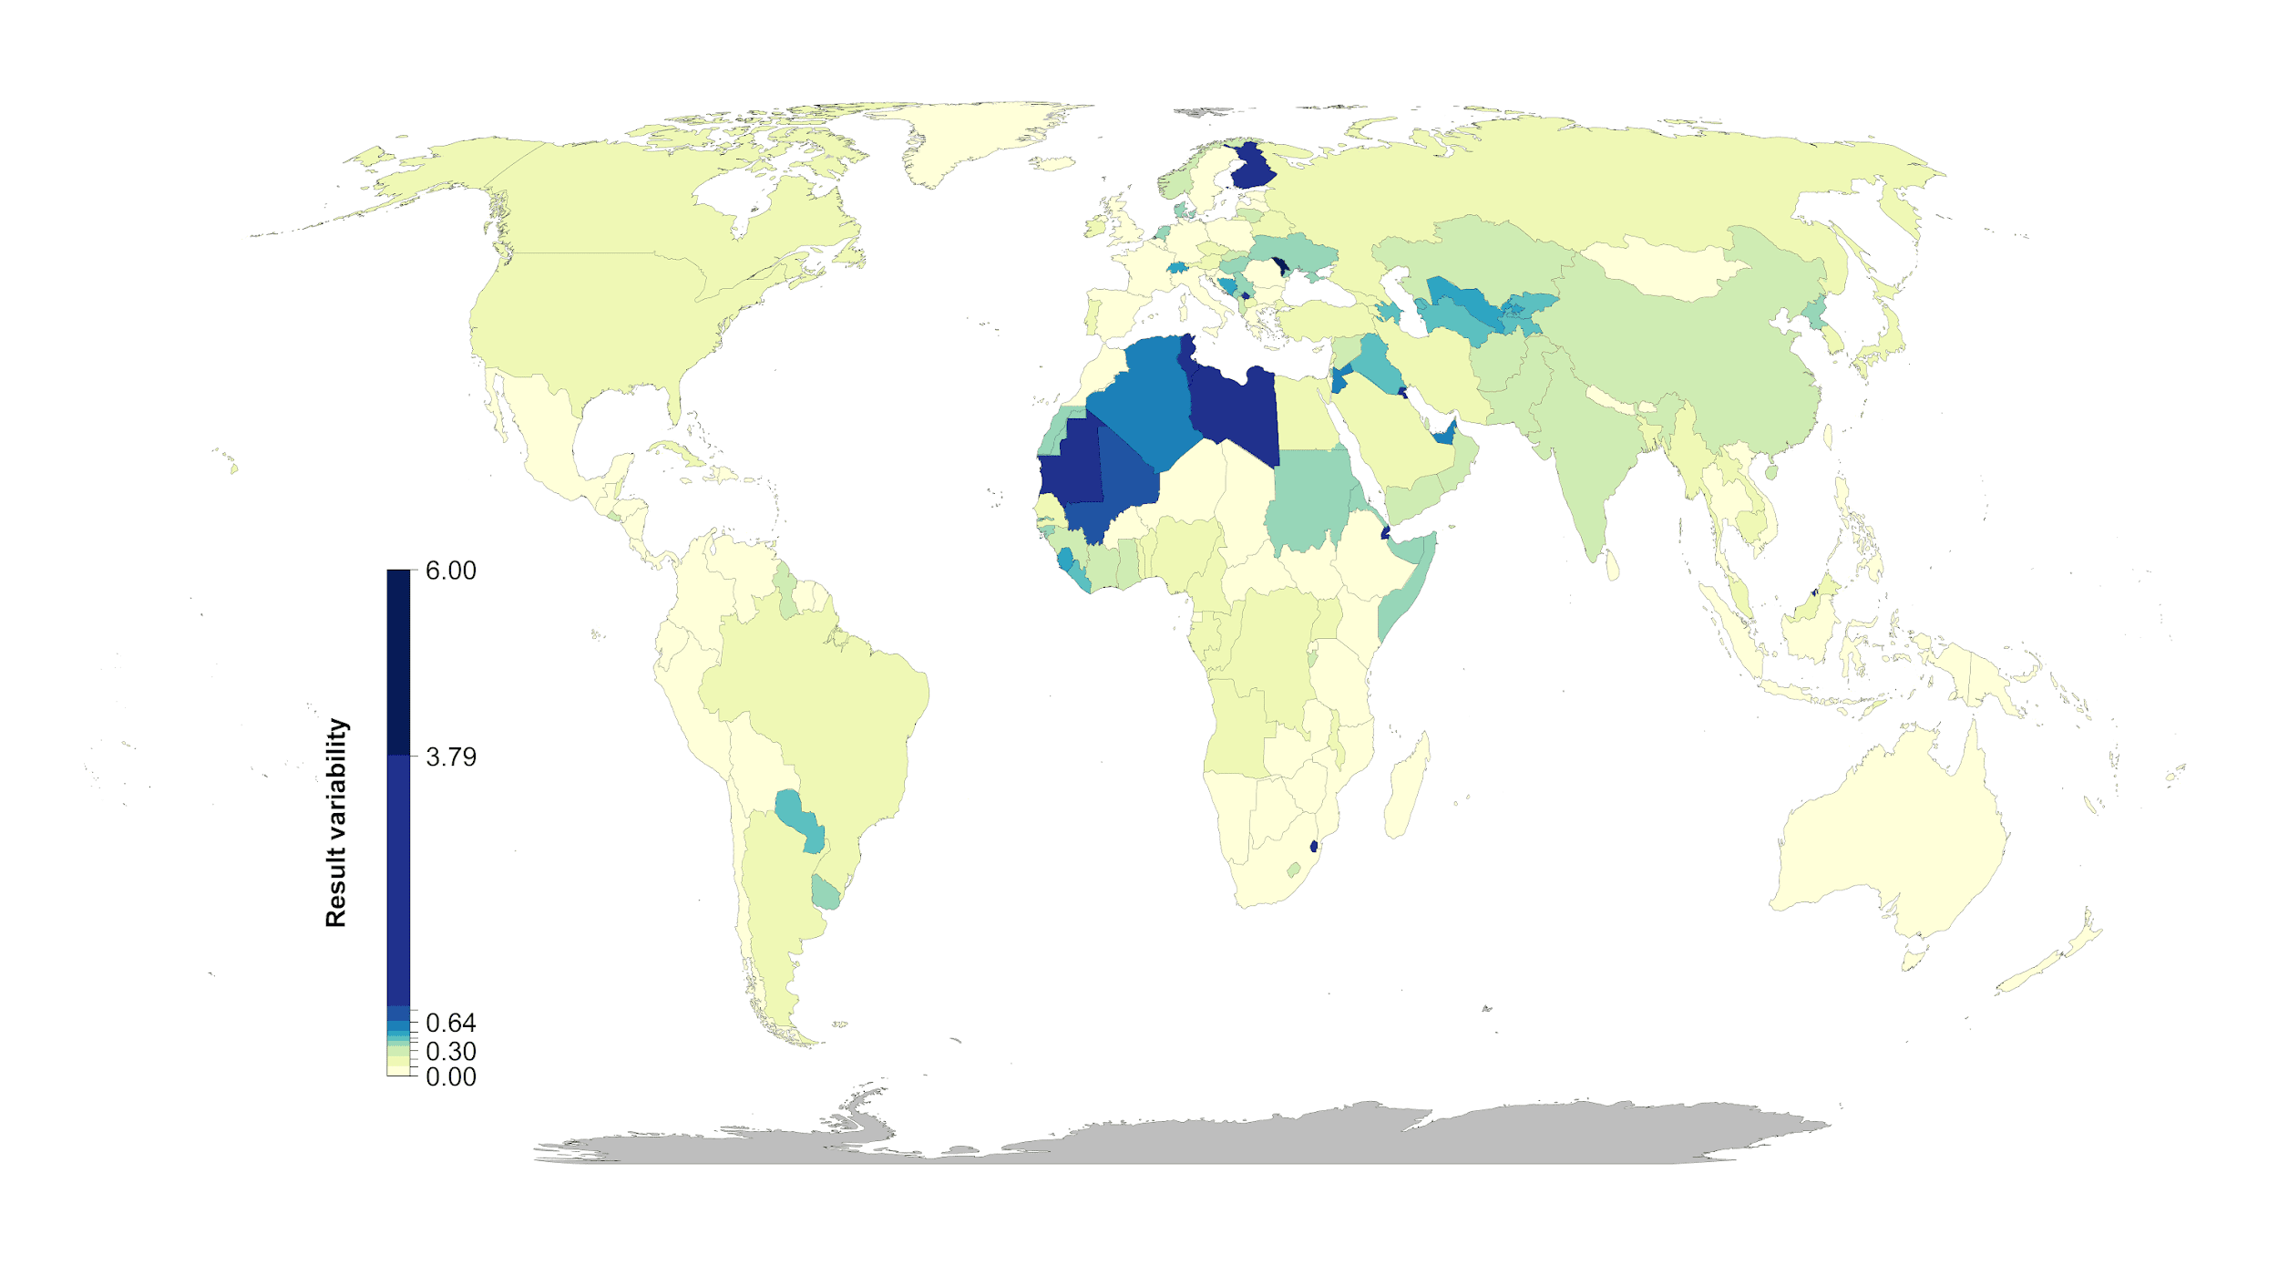
Figure 3: Percent country-level variation between the null scenario and the 15 scenarios including risk. Countries whose results are consistent across the 15 scenarios (e.g., Mexico) have low variation, while countries whose results are less consistent across the 15 scenarios (e.g., Finland) have high variation. The kmeans method (40) was used to generate class intervals for visualization.

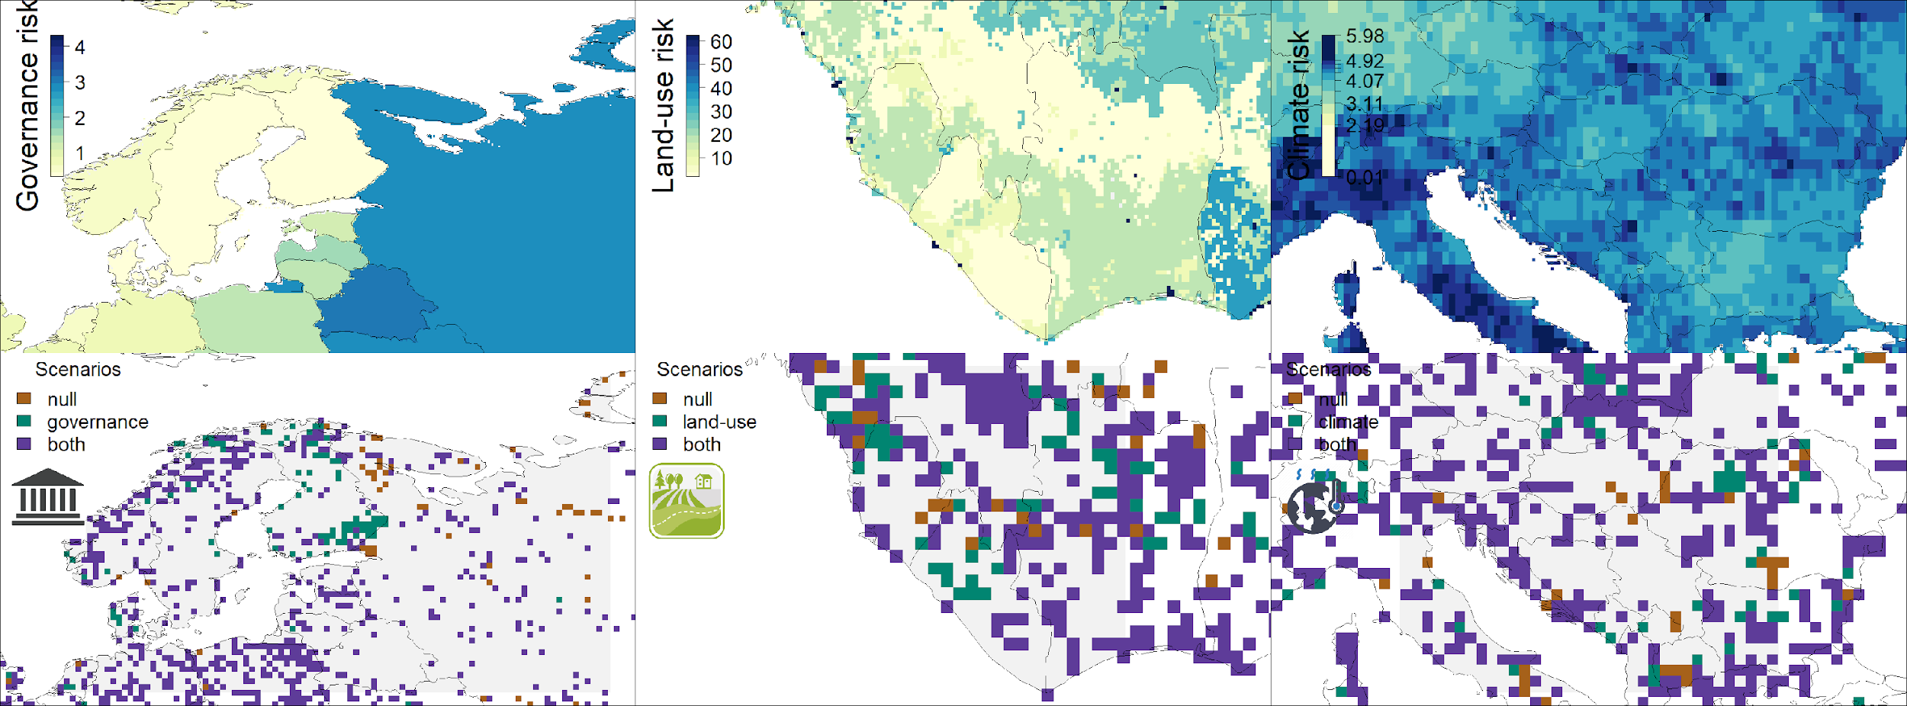

Figure 4: Contrast of using individual risk objectives (governance, land-use, climate) to the null scenario of uniform objective structure. The top panels represent the individual risk data for the focal regions. In the bottom panels brown shows null, green the specific risk objective scenario results, and purple where both scenarios agree. The figures show how the spatial configuration of the solutions changes when risk is considered in a scenario. Governance focus is on Finland and Russia, land-use risk on Sierra Leone and Liberia, and climate risk on Serbia, Hungary and Kosovo.

